**Experiment Title-2.4**

**Student Name: ADITYA RAJ** **UID:21BCS8948**

**Branch: CSE**  **Section/Group: ONBCS703/A**

**Semester: 3rd**

**Subject Name: DBMS Subject Code:21 CSH-214**

**1. Aim/Overview of the practical:**  **Write a query to create a view that shows the average and total orders for each salesman after his or her name. (Assume all names are unique)**

**R1: Salesman**

salesman_id | name | city | commission

-------------+------------+----------+------------

5001 | James Hoog | New York | 0.15

5002 | Nail Knite | Paris | 0.13

5005 | Pit Alex | London | 0.11

5006 | Mc Lyon | Paris | 0.14

5007 | Paul Adam | Rome | 0.13

5003 | Lauson Hen | San Jose | 0.12

**R2: Orders**

ord_no purch_amt ord_date customer_id salesman_id

---------- ---------- ---------- ----------- -----------

70001 150.5 2012-10-05 3005 5002

70009 270.65 2012-09-10 3001 5005

70002 65.26 2012-10-05 3002 5001

70004 110.5 2012-08-17 3009 5003

70007 948.5 2012-09-10 3005 5002

70005 2400.6 2012-07-27 3007 5001

70008 5760 2012-09-10 3002 5001

70010 1983.43 2012-10-10 3004 5006

70003 2480.4 2012-10-10 3009 5003

70012 250.45 2012-06-27 3008 5002

70011 75.29 2012-08-17 3003 5007

70013 3045.6 2012-04-25 3002 5001

**CODE :-**

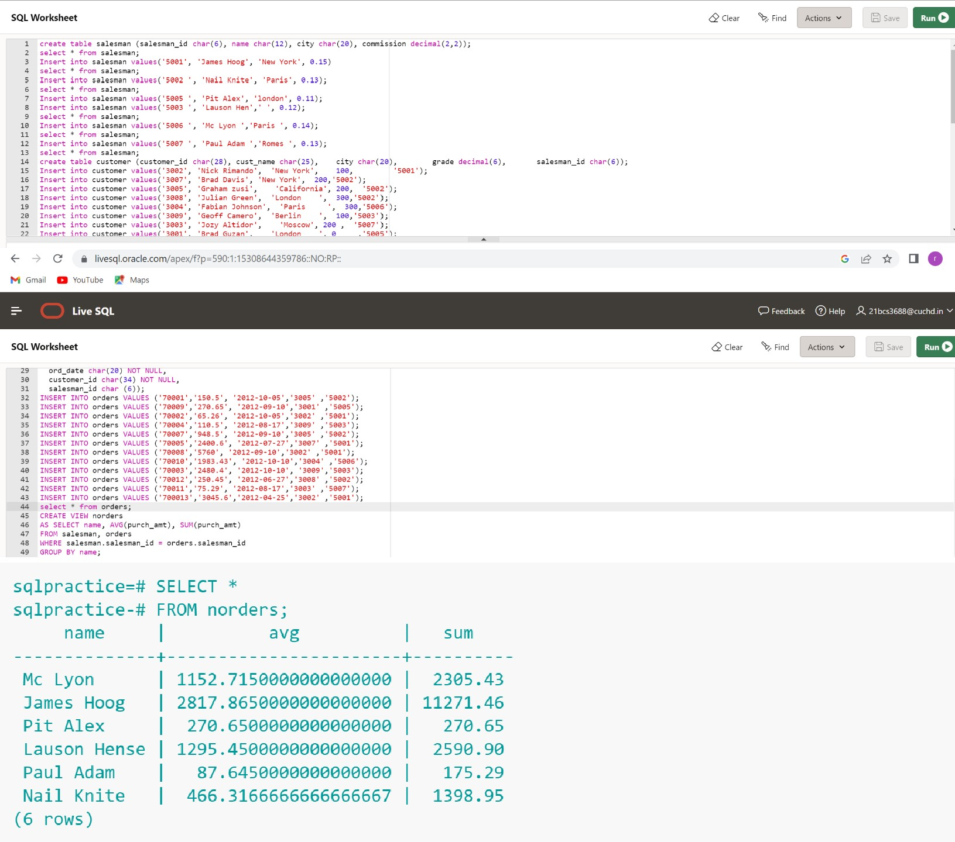

output: